Building a Filter Summary

by Mohit Kumar – Oct 10, 2024

A few days ago, a client exported a specific sheet in PDF format from a dashboard I had created earlier. However, the exported sheet lacked information about the filters applied prior to generating the report. As a result, a request was made to create a filter summary that could be exported alongside the data.

Considering the use case, I immediately recalled a helpful tip shared by Ann Jackson. She suggested leveraging the title of the sheet to include all relevant fields for the summary. By setting the mark type to polygon and incorporating the necessary fields into the title, you can create an effective filter summary that exports seamlessly with the data. This approach works like a charm—what a great tip! However, there is a limitation that we will explore shortly.

Let’s try to replicate the solution.

For the demonstration, I have dummy data related to employee performance.



The figure above represents data for just one region. You can download the data from here.



In this dataset, we have columns for Region, Location, a Level 1-4 hierarchy, Manager, and a few metrics. It’s quite straightforward.

I’d like to highlight the hierarchy: the Quality Assurance team appears across all divisions, and there are other teams with the same name in different divisions. While you may have a dataset with only unique values, I’ve chosen this example to address other scenarios as well.

Now, let’s start building the filter summary.

First create a simple crosstab

* Add Region, Level 4: Employee and Manager fields to Rows.
* Double click and add Performance Rating, Projects Completed and Years of Experience as Measure.
* Add Region, Level 2: Division, Level 3: Team, Level 4: Employee, Manager and Location to filters. Apply the filters to all using this data source.
* With a bit of formatting your crosstab should look like this.

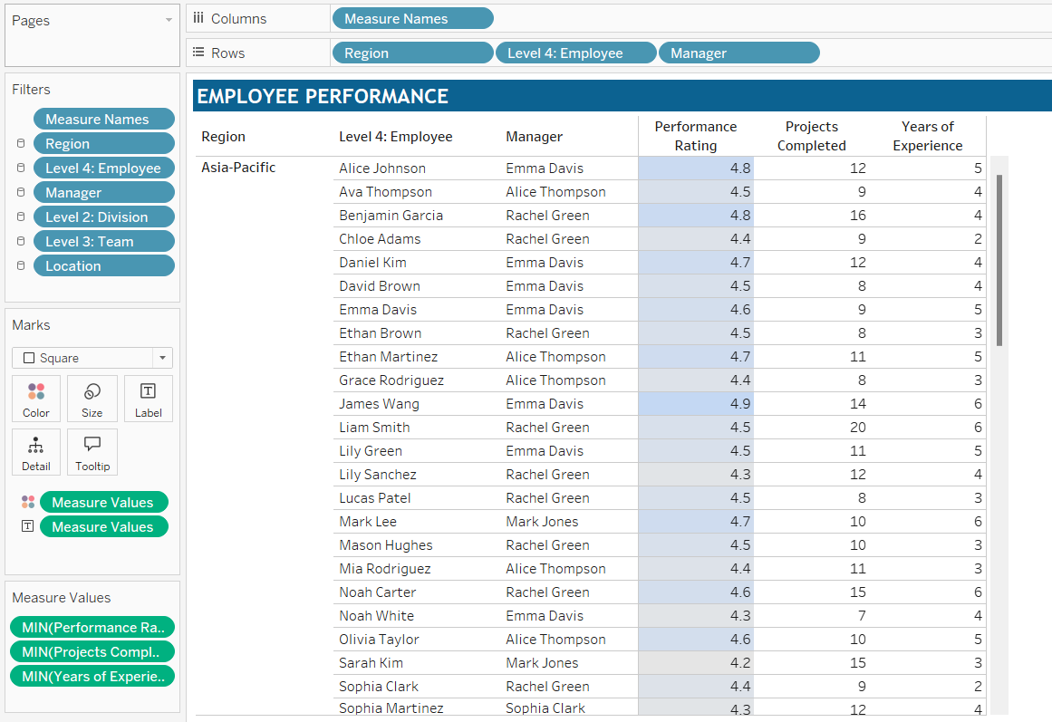

To create a filter summary that can be downloaded along with the sheet, we can use either the title or caption. For this example, I will use the caption.

Enable Caption:

* From the Worksheet menu bar, check the option for Show Caption.

Edit the Caption:

* To keep this concise, we’ll include only Location, Division, and Team in the filter summary.
* Edit the caption to add a title, and from the insert button, include Location, Level 2: Division and Level 3: Team.

Format the caption as needed so that it appears as shown below:

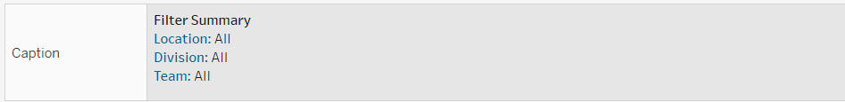

That’s it. Your filter summary is ready.

To download a PDF for a specific sheet, you need to publish the visualization to a server. I created a simple dashboard and added a download button for this purpose.

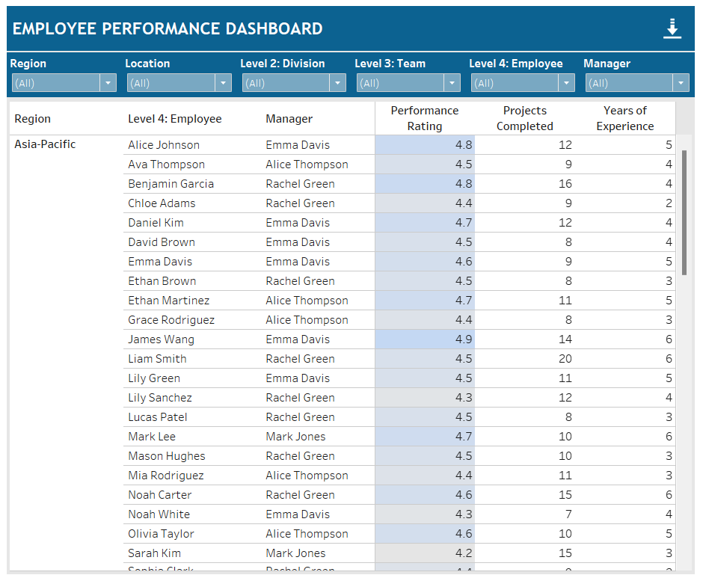

Now, let’s filter something and export to see how it looks.

Deselect London, Paris and New York from Location.

Deselect Help Desk Support and Training and Development from Level 3: Team.

Download the sheet. You can use below configuration for reference.

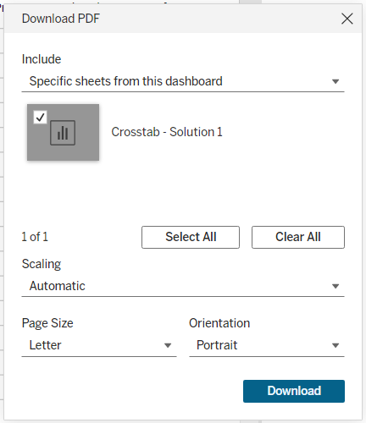

Let’s look at the downloaded PDF.

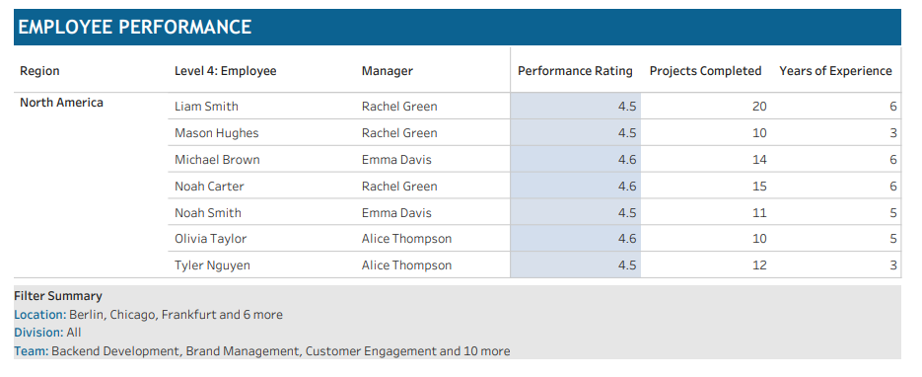

This looks pretty good. However, a limitation is that when more than three values are selected for a field, it displays "and n more" instead of the actual values. While this might be sufficient in some cases, there are situations where you may need to show all selected values. For instance, if someone shares this sheet, it won’t provide complete information regarding the selected Locations or Teams.

Now, we want to generate a filter summary that captures all selected values for a field. With the requirements clear, let’s try to build one.

Create another sheet and rename it to Filter Summary.

Add the fields for which we want to generate the summary to the Rows. These fields are Location, Level 2: Division, and Level 3: Team, in that order. Make sure to sort Location in descending order.

Next, for each field, we will create a table calculation that appends the previous value to the current value based on whether it matches or exists.

**@TC | Location**

IF LOOKUP(MIN([Location]), -1) = MIN([Location]) THEN ""

ELSE MIN([Location]) + IIF(FIRST()=0, "", ", ")

END

+

PREVIOUS_VALUE("")

Since Location is the first field in the grouping, all duplicate values will be placed together. This allows us to compare whether the current value matches the previous cell's value. If it does, we can use the previous value; if it doesn’t, we will append the current value to the previous value, separated by a comma.

For the remaining fields, duplicate values can appear anywhere based on the hierarchy. Therefore, we need to check if the current value exists in the appended previous cell’s value. We need to tweak our calculation slightly.

**@TC | Division**

IF CONTAINS(PREVIOUS_VALUE(""),MIN([Level 2: Division])) THEN ""

ELSE MIN([Level 2: Division]) + IIF(FIRST()=0, "", ", ")

END

+ PREVIOUS_VALUE("")

Create a similar calculation for other remaining fields.

**@TC | Team**

IF CONTAINS(PREVIOUS_VALUE(""),MIN([Level 3: Team])) THEN ""

ELSE MIN([Level 3: Team]) + IIF(FIRST()=0, "", ", ")

END

+ PREVIOUS_VALUE("")

Add these fields to your view, ensuring that all fields are computed using "Table (down)."

You should see a similar view.

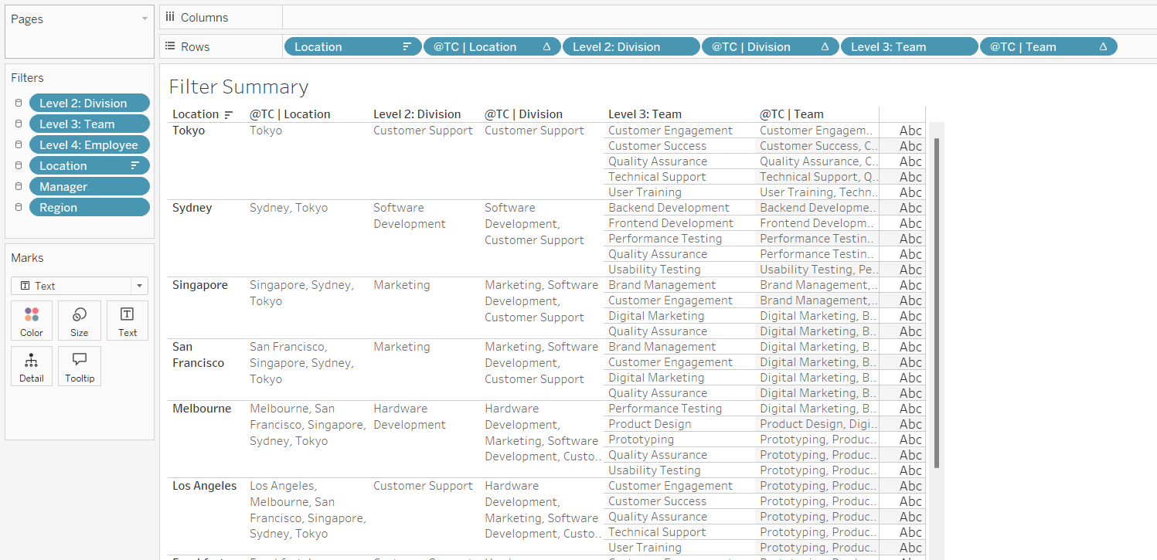

Look at the last row of your table; the table calculation (TC) contains all available values for each field. Now, simply filter out the last row of your table.

Create below Boolean calculation:

@LAST

LAST() = 0

Add it to filter, select TRUE values. Make sure it is computed using "Table (down)."

We are close. We have the fields ready. Now, let’s create three parameters for each field, which we will update with these table calculation (TC) values. Use below for your reference.

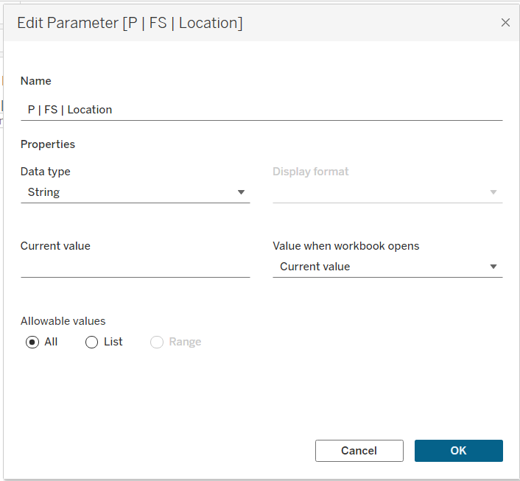

Uncheck “Show Header” for all the fields.

Change the mark type to **Shape** and assign any shape you prefer. I’ve formatted the sheet using toggle calculations and shapes; you can do this as well, but for the sake of simplicity, it’s not necessary.

Add this sheet to your dashboard. I have placed it in the top right corner, to the left of the download button.

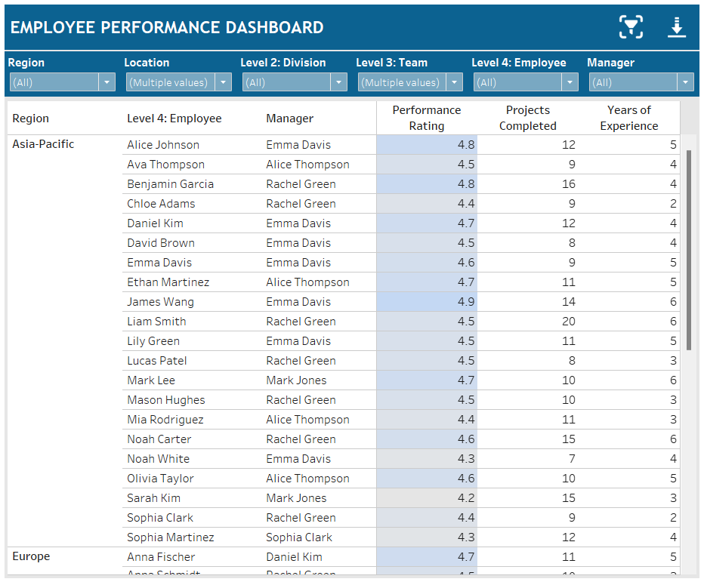

Add a parameter action to update the three parameters we created earlier with the table calculation (TC) values. Use the following as a reference:

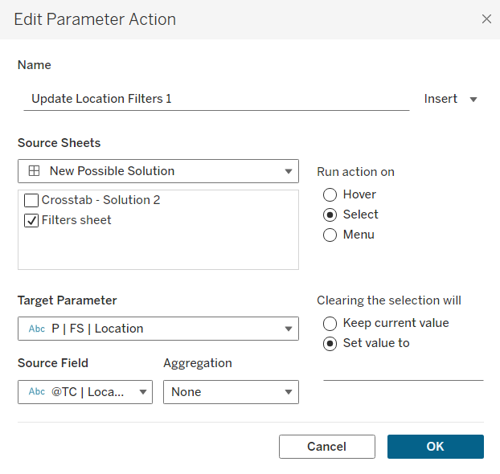

We are almost done. Just update the caption of your crosstab. Instead of fields, use the parameters.

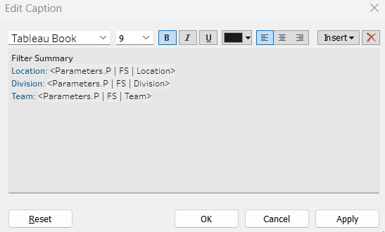

And we are done!

Initially the caption will not show any summary as we must click on the **Filter Summary** sheet to populate the parameters.

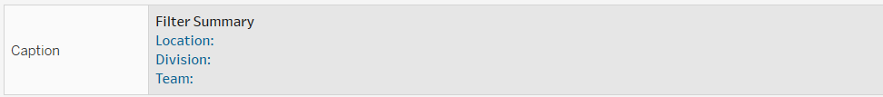

Let’s test it.

Go to your dashboard and click on the shape from Filter Summary sheet.

Download only the crosstab sheet. Below is the output:

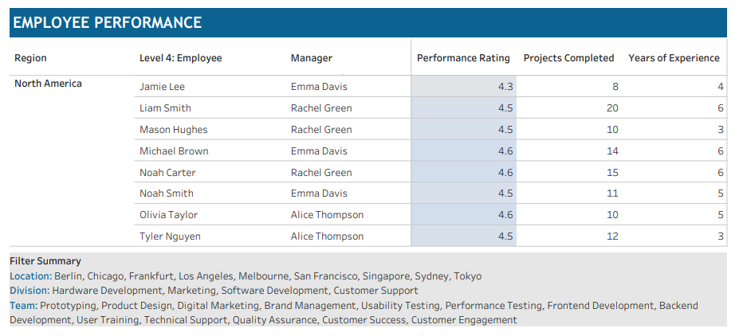

The Filter Summary now displays all available values.

This works, but if you look closely, you'll notice that, apart from Location, the values for all other fields are not sorted. Additionally, this approach requires creating another sheet, and users must click the icon to capture the filters each time there is a change, as it will not update automatically.

So, while this solution works, Ann’s approach is simpler and more effective (She’s a Hall of Famer for a reason.) unless there’s a need to display all values. There are many great minds in the community, and I am sure someone will find a way to optimize this or develop a better solution.

Thanks!

Mohit